Our mission is to provide a game with humor and adventure  Bioethics the text adventure provides interest to the future. It gives a possibility of comic relief and opens up a door for a full series. |  |  | A Text Adventure To Live For  #TextToLive  LAMM  2 Oakwood  Ypsilanti MI 48198 |  | Bioethics  - A fun, witty adventure for those who want to a laid back game.

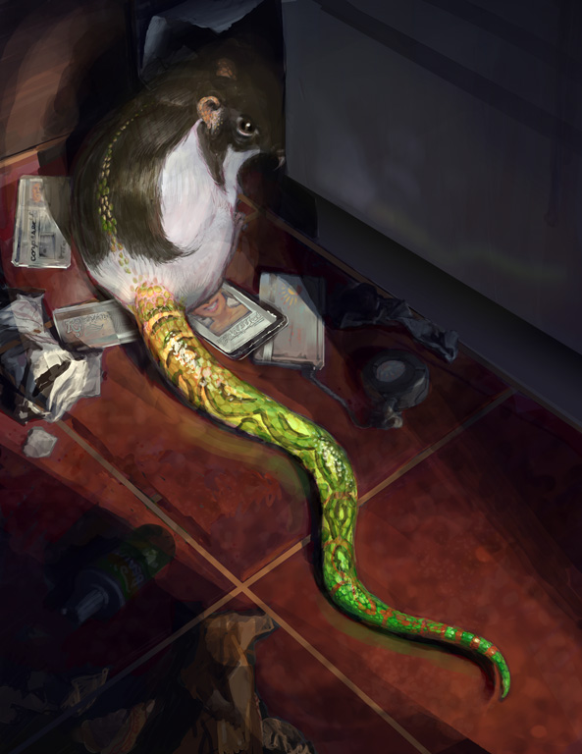  Make It Yours  Our game provides the basics to understanding what the risks are to bioethics. We want to provide a fun witty game to gather interests of players | Any animal you can think of  you can make.  Focus On What You Want  Our text adventure focuses on allowing you to choose what you want and who you want to be in the end while assisting with information while playing |  | Why  We want to offer a game that those who are in a mood to laugh want. We offer a game that it funny and allows the player to go through an adventure that ends in humor.  Who Is Our Key audience?  Our key audience is targeted toward  - College students  - Youth, early teenagers and high school  - Those interested in a fun new path  Contact Us  LAMM  2 Oakwood  Ypsilanti MI 48198  734-867-5309  LAMM@Bioethics.com  BioethicsTheGame.com

